Rahim Muhammad Syed 18k-0122  
Syed Abdullah Muzaffar 18k-0169  
Muhammad Ahmed Khan 18k-1103

OS PROJECT **HYPERVISORS**

**BENCHMARKS**

**Testing Methodology**System utilized: Sam PC  
All tests were performed with no additional tasks running on host PC (except for TeamViewer and chrome).  
All the virtual machines were assigned 7.6GB of RAM, all 4 Processor Cores and 20GB of Drive Space (except for Hyper-V which was predetermined).  
In addition, reboots were performed between each Hypervisor Switch.  
For geekbench multiple runs were done to eliminate any randomness.

**Hypervisors Tested:**

* HyperV
* VMware
* VirtualBox

**Tests Ran:**

* hdparm
* sysbench
* [GeekBench](Benchmarks/geekbench.txt)

**“hdparm”  
 a command line program for Linux to set and view ATA hard disk drive hardware parameters and test performance**

**Installing hdparm**

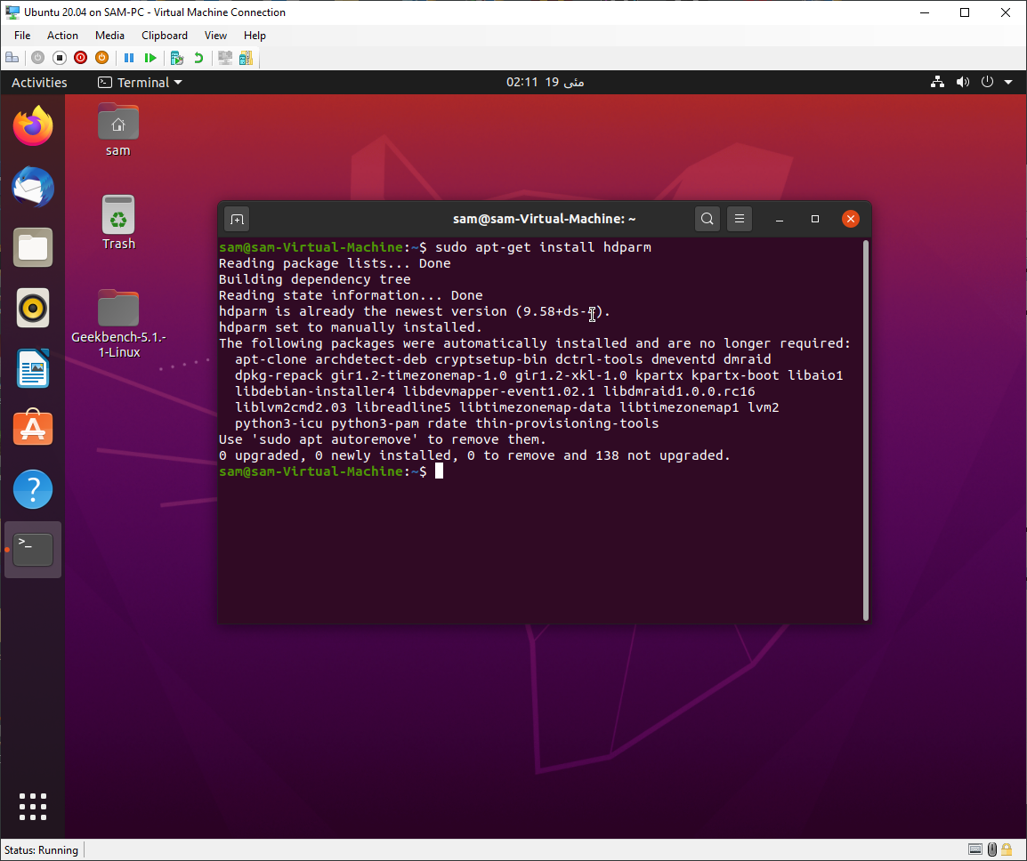

1. **HyperV results**

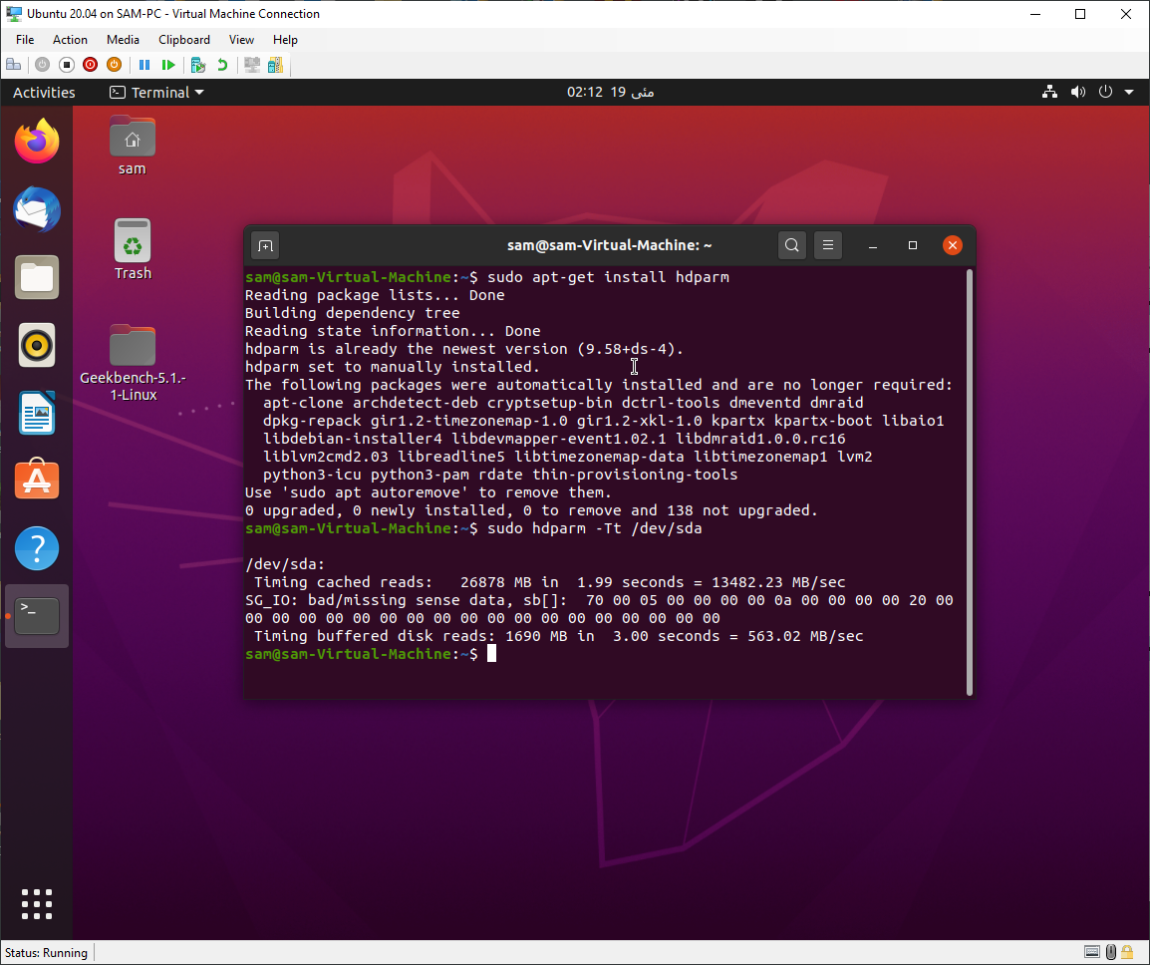

1. **VMware results**

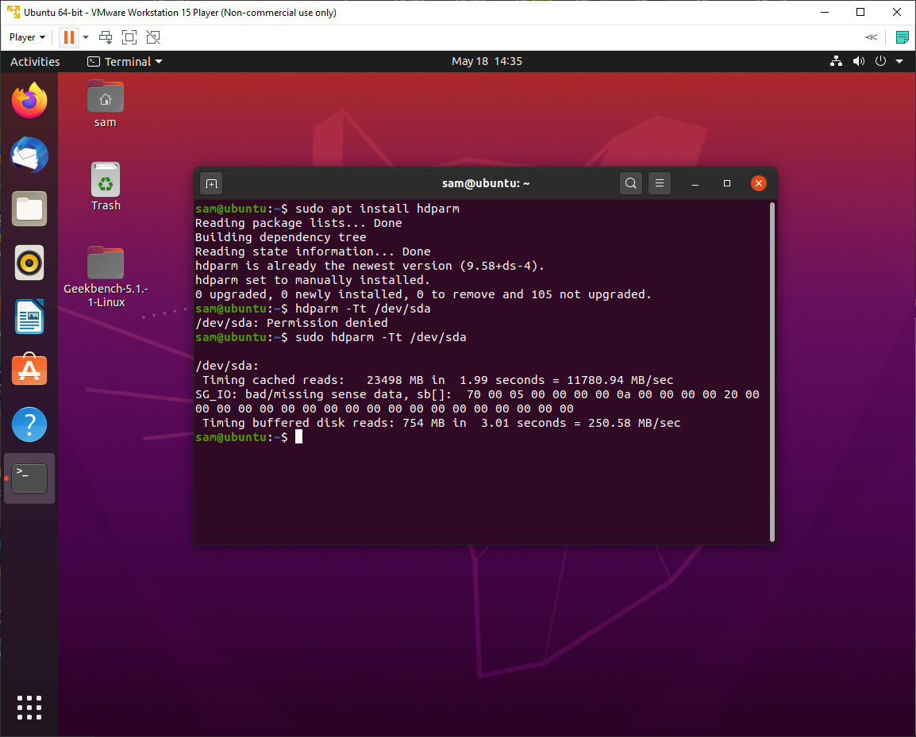

1. **VirtualBox results**

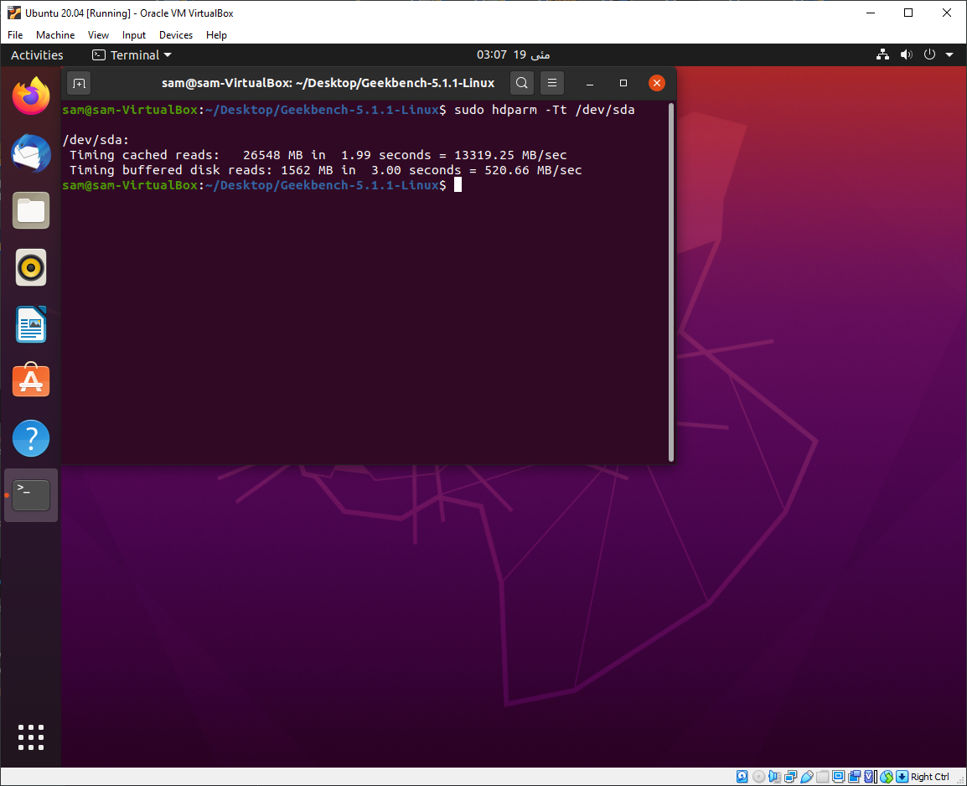

**“sysbench”** a scriptable multi-threaded benchmark tool based on LuaJIT, frequently used for database benchmarks.  
  
**Installing sysbench**

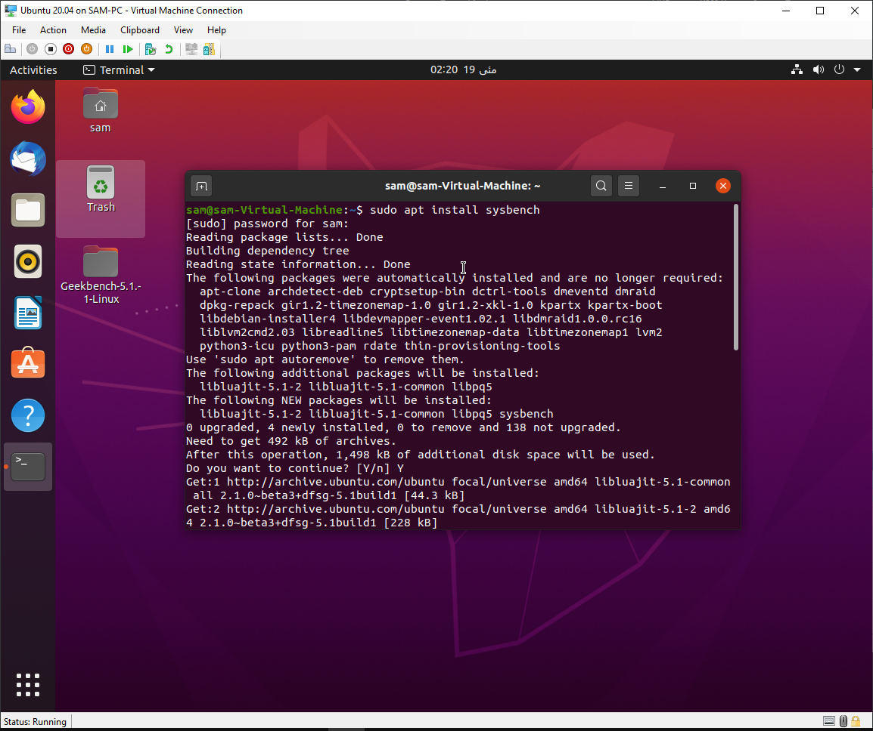

1. **CPU**
2. **HyperV results**

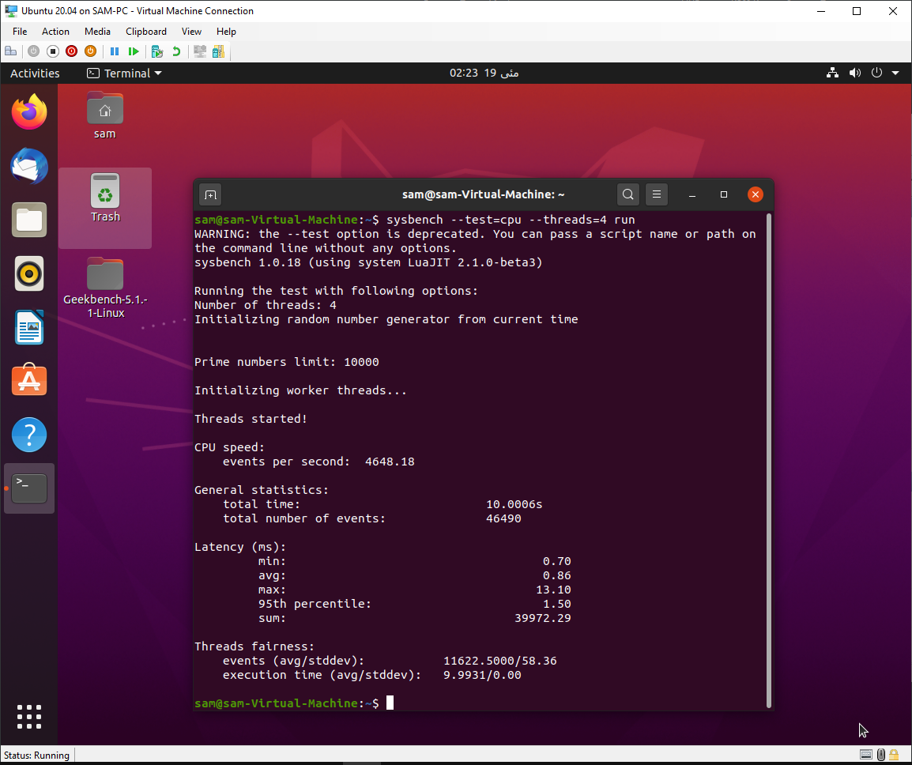

1. **VMware results**

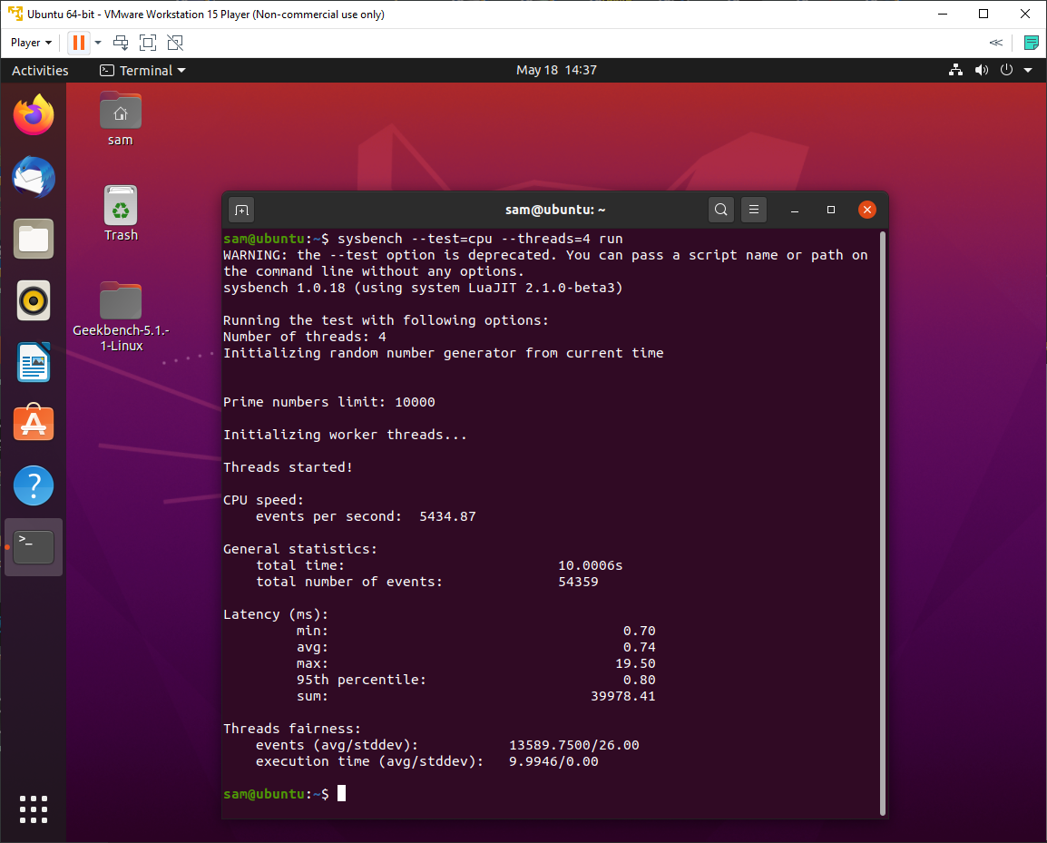

1. **VirtualBox results**

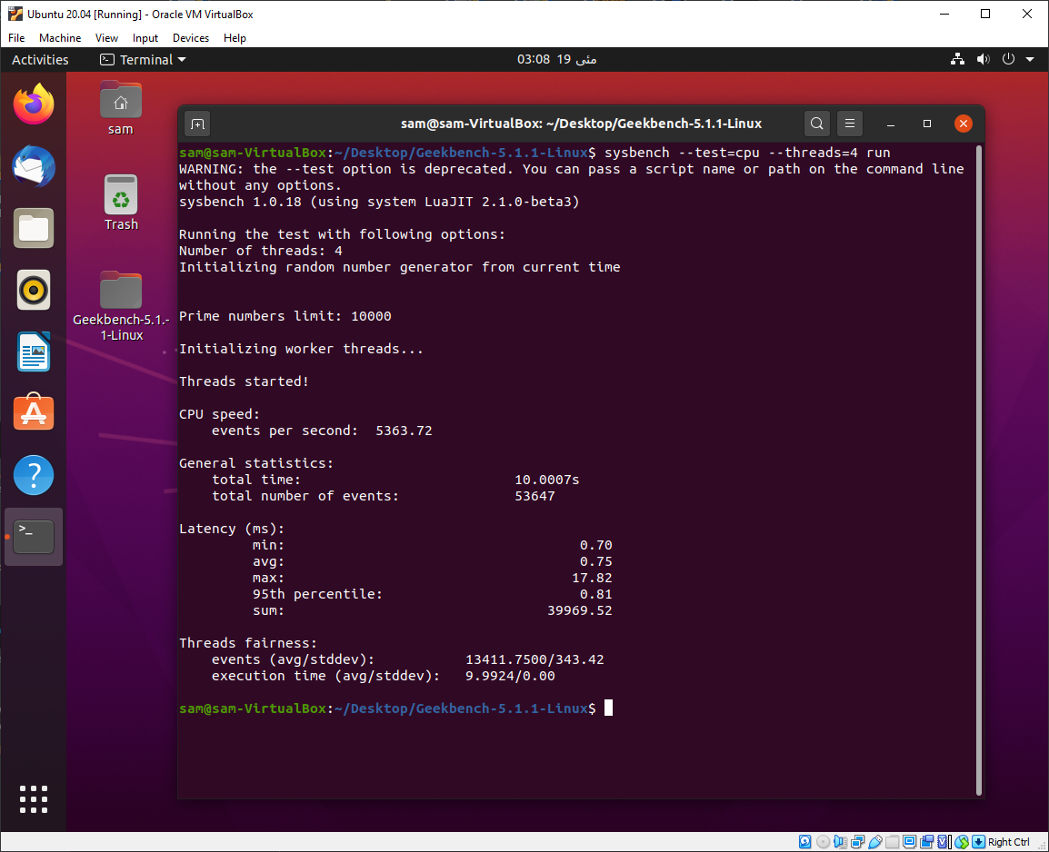

1. **Memory**
   1. **HyperV results**

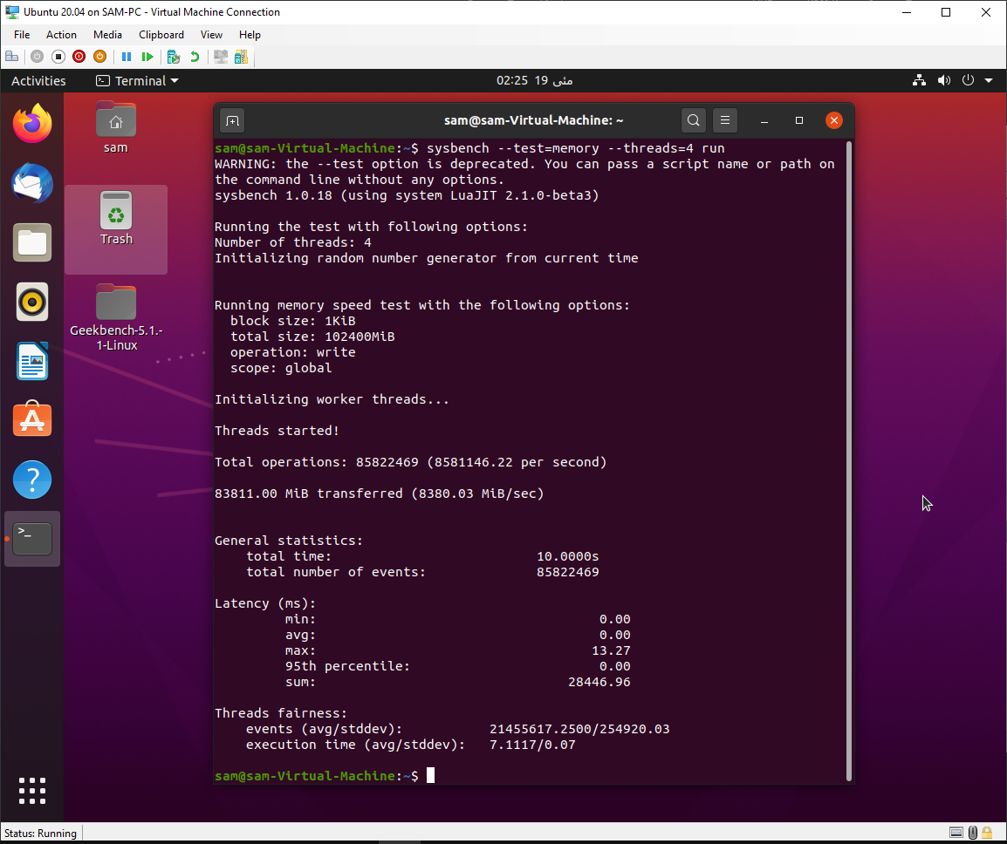

* 1. **VMware results**

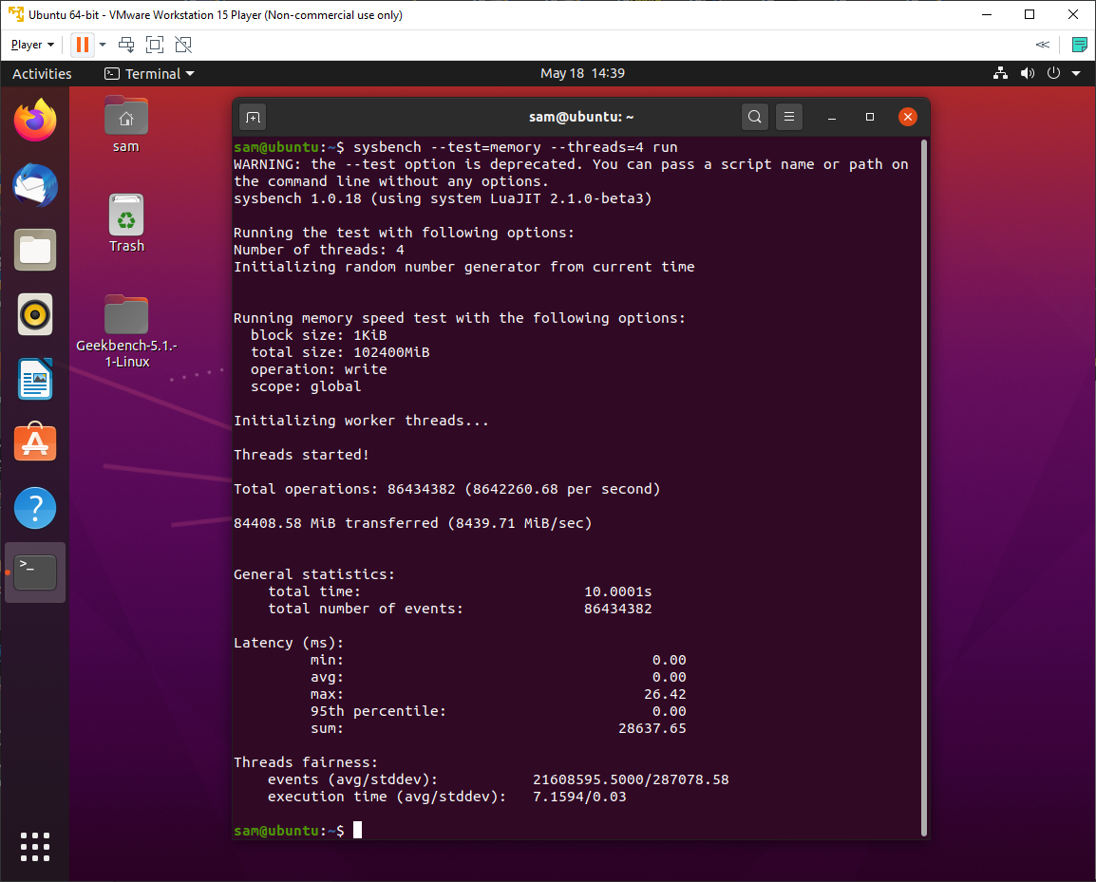

* 1. **VirtualBox results**

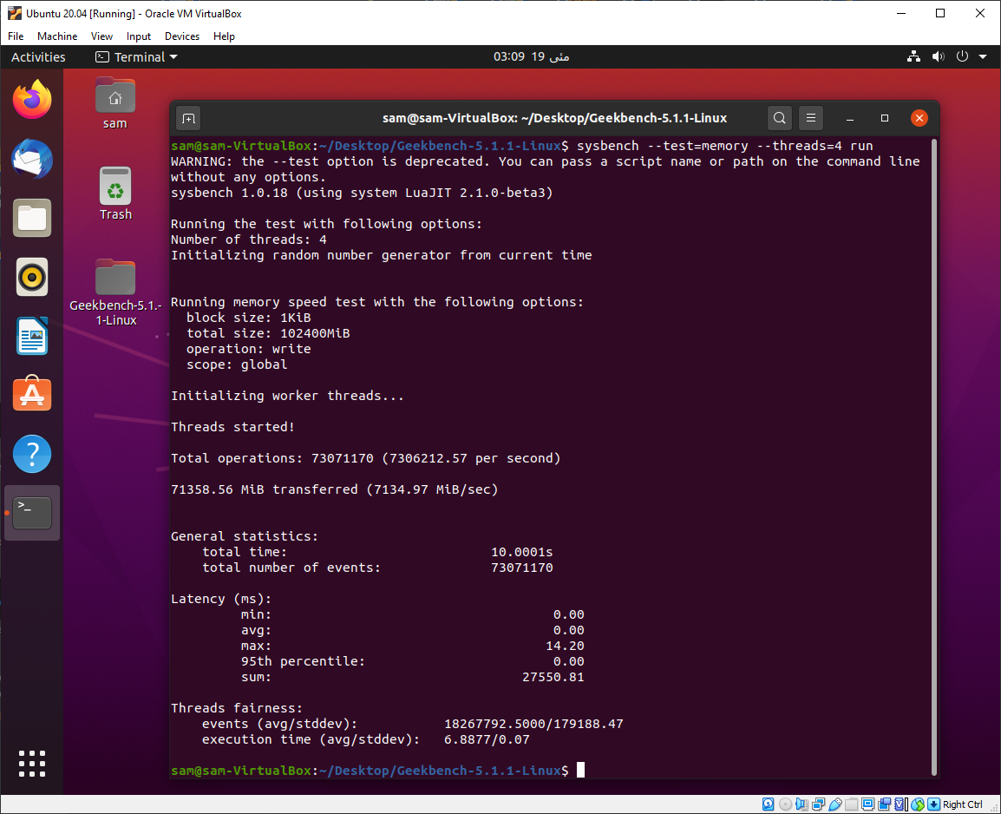

**GeekBench:**

**Type I**

[**HyperV Dynamic Memory**](https://browser.geekbench.com/v5/cpu/2209842)

[**HyperV Static Memory 1**](https://browser.geekbench.com/v5/cpu/2210748)

[**HyperV Static Memory 2**](https://browser.geekbench.com/v5/cpu/2210786)

**Type II:**

[**VMware 1**](https://browser.geekbench.com/v5/cpu/2210361)

[**VMware 2**](https://browser.geekbench.com/v5/cpu/2210503)

[**VirtualBox 1**](https://browser.geekbench.com/v5/cpu/2211217)

[**VirtualBox 2**](https://browser.geekbench.com/v5/cpu/2211241)

**Reference Scores (Host):**

[**Windows (Host) 1**](https://browser.geekbench.com/v5/cpu/2210429)

[**Windows (Host) 2**](https://browser.geekbench.com/v5/cpu/2210607)

[**Windows (Host) HyperV enabled**](https://browser.geekbench.com/v5/cpu/2210699)